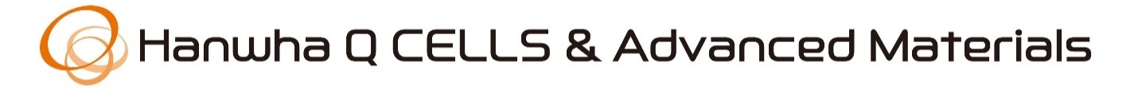The 5th Hanwha Q CELLS & Advanced Materials Non-tenured Faculty Award (2019)

The Hanwha Q CELLS & Advanced Materials is pleased to announce the 5th Hanwha Q CELLS & Advanced Materials Non-tenured Faculty Award. To demonstrate Hanwha’s commitments to promote cutting-edge research and innovation in Materials Chemistry & Processing, this award will support the career development of non-tenured young faculty particularly in the following areas.

- Polymer Composite Materials, Nano-composites (Aerospace, Automotive, Defense & SOC applications)
- Micro/Nano-cellular Materials
- 3D Printing & 3D Printing materials
- Simulation for Materials properties & Molding Process
- Solar Cell/Module Materials
- Flexible Circuit Materials
- Adhesive for Electric vehicle

Award
- Eligibility: Non-tenured faculty with Korean heritage in North America, United Kingdom and Germany working in the chemistry, chemical engineering, Materials science and engineering and other related disciplines.,
- No. of Awards: 2 Awards
- Award amount: $12,000 as an unrestricted gift funding
- The awardee is required to attend and present a talk in Korea at “Hanwha Q CELLS & Advanced Materials non-tenured faculty award symposium” in the summers of 2019 and 2020.

Application Package
- Short Bio-sketch including a comprehensive list of publications
- Summary of research interest (max 1 page)
- Descriptions of research interest (max 5 pages)
- Application package must be submitted as a single word document file.

Timeline
- Submit your package to hanyoung@hanwha.com by March 31, 2019
- Announce the Awardees by April, 2019
- The 5th Hanwha Q CELLS & Advanced Materials Non-tenured Faculty Award in Korea (tentatively scheduled on June 10-11, 2019.) Flight and hotel expenses will be separately provided by Hanwha

The non-tenured faculty in his/her 3rd – 5th years as a faculty are particularly encouraged to submit the application package for the consideration.
We encourage you to submit the application package again, even if the non-tenured faculty had applied before.

